# SITE CONNECTIVITY CHECKER / WEBSITE MONITORING PROJECT GURUKUL

#### **About website monitor in python project:**

Sometimes we go to a website only to find it down or under maintenance. This can get frustrating real quick when we need some crucial information from the website and that is when a website monitor can help. We simply create a python program to notify us with the status of the website through email

#### **Website monitor in python project:**

To implement the project, we need to use libraries that already are in python by simply importing.

#### **Project Prerequisites:**

This project is for beginners, hence no prerequisite knowledge is required

#### **Download code:**

You can download the source code from the given link: <add link>

#### **Project File Structure:**

Below is the flow of the project.

1. Importing necessary libraries
2. Declaring functions to send emails and monitor website
3. Read the inputs

##### **Importing necessary libraries:**

#Import libraries

import urllib.request

import smtplib,time, hashlib

**Code Explanation:**

* **import urllib.request:** To open a website and obtain the status, we use urllib’s request.
* **smtplib:** To establish an SMTP connection with gmail, we use the library.
* **time:** To create the delay to monitor between, we use time.
* **hashlib:** To create hashcodes using which we can observe any changes in the website.

##### **Declaring functions to send emails and monitor website:**

#Function to send email

def send_email(email_string):

#Fill credentials for sender's email and receiver's email

email_from = 'enter sender\'s email'

password = 'enter password'

email_to = 'enter reciever\'s email'

#Enter subject line

subject = "Status of website"

#Connect to gmail's smtp server

smtp_server = smtplib.SMTP_SSL("smtp.gmail.com", 465)

#Login to the gmail server

smtp_server.login(email_from, password)

#Content of email

message = f"Subject: {subject}\n\n{email_string}"

#Send email through the smtp server

smtp_server.sendmail(email_from, email_to, message)

#Close the server connection

smtp_server.close()

**Code explanation:**

* **def send_email(email_string):** Declare the function send_email() with the parameter email_string.
* **Email_from, password, email_to:** Enter email details of the sender and the receiver’s email
* **subject:** Enter subject of the email. It is optional, but a good practise to keep one.
* **smtp_server = smtplib.SMTP_SSL("smtp.gmail.com", 465):** Connect to the smtp server of gmail on port 465 using smtplib.SMTL_SSL. SSL is a security certificate
* **smtp_server.login:** Connect to the server by logging in using the credentials.
* **Message:** Create a message to send in the body of the email
* **smtp_server.sendmail:** Send the email using sendemail() with the parameters: sender’s email, receiver’s email and the message to send and close the server connection using close()

#Monitor the website

def monitor_website():

#Run the loop to keep monitoring

while True:

#Visit the website to know if it is up

status = urllib.request.urlopen(input_website).getcode()

#If it returns 200, the website is up

if status != 200:

#Call email function

send_email("The website is down")

else:

send_email("The website is up")

#Open url and create the hash code

response = urllib.request.urlopen(input_website).read()

current_hash = hashlib.sha224(response).hexdigest()

#Revisit the website after time delay

time.sleep(time_delay)

#Visit the website after delay, and generate the new website

response = urllib.request.urlopen(input_website).read()

new_hash = hashlib.sha224(response).hexdigest()

#Check the hash codes

if new_hash != current_hash:

send_email("The website changed")

**Code explanation:**

* **def monitor_website():** Declare the function monitor_website() to monitor the website.
* **while True:** To keep monitoring until the user terminates the program, create an infinite while loop
* **status = urllib.request.urlopen(input_website).getcode():** Open the website the user wishes to monitor and using getcode(), obtain the status of the website. If it returns 200, it implies the website is up and not otherwise.
* **if status != 200:** If the status code is not 220, send an email stating the website being down or so on.
* **current_hash = hashlib.sha224(response).hexdigest():** Create a hash code for the retrieved website using SHA224.
* **time.sleep(time_delay):** Wait for a time interval before rechecking the website and obtaining its status
* **response, new_hash:** Revisit the website and create a new hash code
* **new_hash != current_hash:** Check if the hash codes are similar and send an email if they are not.

##### **Read the inputs:**

#Read the website and read time interval

input_website = input('Enter the website to monitor: ')

input_website = 'https://'+input_website

time_delay = int(input('Enter the time interval to check website: '))

#Monitoring website

monitor_website()

**Code explanation:**

* **input_website:** Read the website to monitor from the user and append ‘https://’ to the given website.
* **time_delay:** Read the time interval from the user
* **monitor_website():** Call the function to monitor the website

#### **Project output:**

Run the program and view your output

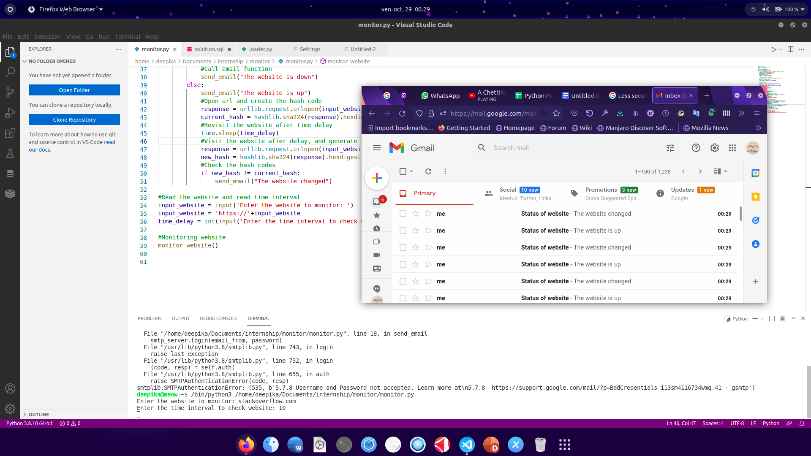

#### **Summary**

Thus we implemented a website monitor that will notify the user when there occurs a change in the website or when a website that was down, comes up.

Comments-

* You’ve not used the word ProjectGurukul while developing the project.